 | Banco Santander Internacional  1401 Brickell Avenue, Suite 1500 - Miami FL 33131

Project Implementation Plan
Change ID | RLSE1270306
IT Manager | Jose Luis Martinez Avial
Business Manager | Ted Fernandez
Requested by | Ted Fernandez
Tested by | Jinen Andee
Assigned to | Jinen Andee
Summary | ND.DEAL Implementation

Special tasks

Pre-implementation tasks | N/A
During Implementation tasks | Install BCON BDER001-RLSE1270306.ND.DEAL.01  Authorization of all records
Post-implementation tasks | N/A

Description/Functional Requirements

This requirement aims to create a new revenue stream for BSI Miami with the introduction of the Non Delivery Forward business.

Justification/Requirements Analysis

The new business of ND Deals requires a segregation in terms of which currencies can be used.

Implementation

[Step 1]: Core Updates Installations:

Check from SPF if the following core updates has been installed.

LIST F.T24.UPDATE.RELEASE 'R11_NDF_Trading_3' 'R11_ST_Customer_12' DATE.TIME

Command
bash-5.2$ LIST F.T24.UPDATE.RELEASE 'R11_NDF_Trading_3' 'R11_ST_Customer_12' DATE.TIME
bash-5.2$

We have to identify the following was installed:
R11_ST_Customer_12_SUN.tar
R11_NDF_Trading_3_SUN.tar

If no Records found, place the packages mentioned below in the following folder:

T24Updates-2025-10-3-75.zip
T24Updates-2025-11-18-1117.zip

Path: bnk/bnk.run/updater/updates

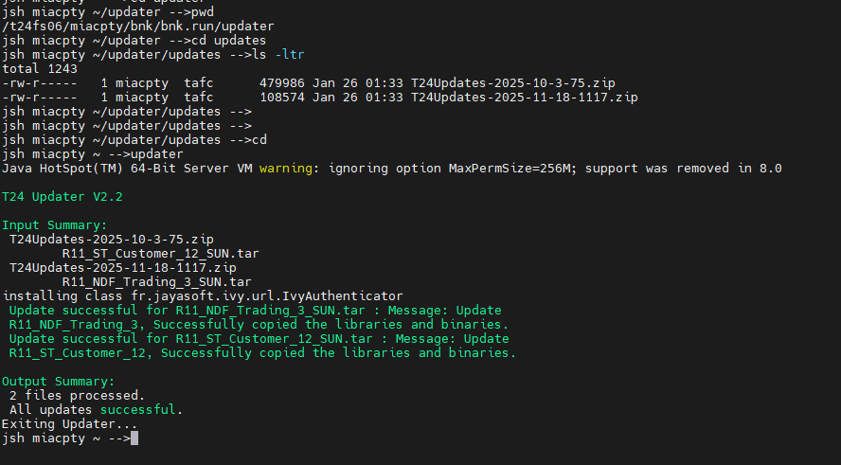

Start the service: BNK/T24.UPDATES

To Ensure the updates have been installed, the IDs can be checked in T24 Table: T24.UPDATE.RELEASE

LIST F.T24.UPDATE.RELEASE 'R11_NDF_Trading_3' 'R11_ST_Customer_12' DATE.TIME

IDs:
R11_NDF_Trading_3
R11_ST_Customer_12

The date.time of installation will show the current date and time.

Authorize the STANDARD.SELECTION DE.ADDRESS record:

STANDARD.SELECTION,RAD A DE.ADDRESS

[Step 2] Creation of folders

Check if below folder exist
cd ../bnk.interface/export/NDF/DAILY

If not, command is:

Command
bash-5.2$ cd ../bnk.interface/export
bash-5.2$ mkdir NDF
bash-5.2$ cd NDF
bash-5.2$ mkdir DAILY
bash-5.2$ cd

Check if below folder exist
cd ../bnk.interface/import/OTHERS/ACONTROL/FIXING.RATES

if not, command is:

Command
bash-5.2$ cd ../bnk.interface/import/OTHERS/ACONTROL/
bash-5.2$ mkdir FIXING.RATES
bash-5.2$ cd FIXING.RATES
bash-5.2$ mkdir in
bash-5.2$ mkdir out
bash-5.2$ mkdir old
bash-5.2$ mkdir queue
bash-5.2$ cd

[Step 3] Verify if the following categories are created
LIST F.CATEGORY WITH @ID EQ 13121 13122 14421 14423 14452 14453 20050 53029 53028 53040 53041 53042 BY @ID ONLY

12 Records must be available.

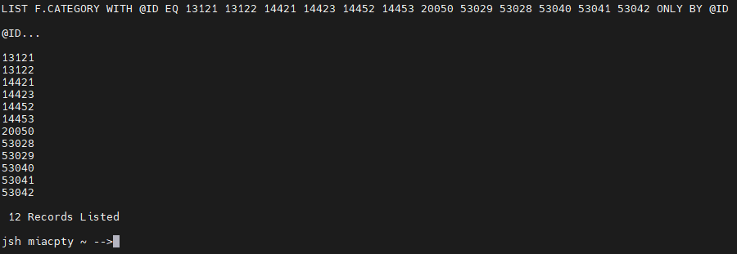

[Step 4] Installation BCON BDER001-RLSE1270306.ND.DEAL.01

[Step 4.1] Modify the record CURRENCY from table LOCAL.REF.TABLE to add below field
LOCAL.REF.TABLE,RAD CURRENCY
FIELD | VALUE
1 6 Local Table No | NDF.FIX.DATE
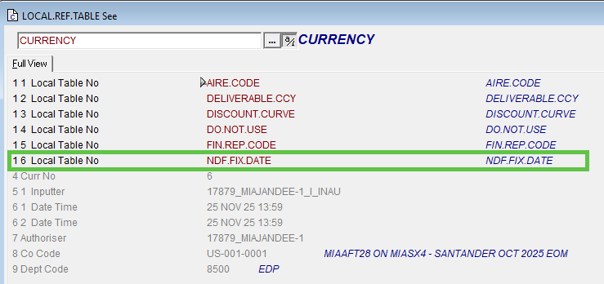
Modify the record ND.DEAL from table LOCAL.REF.TABLE to add below fields:
LOCAL.REF.TABLE,RAD ND.DEAL
FIELD | VALUE
1 1 Local Table No | NDF.STATUS
1 2 Local Table No | FX.ID.MUREX
1 3 Local Table No | UTI.ID
1 4 Local Table No | MKT.BUY.SELL.IND

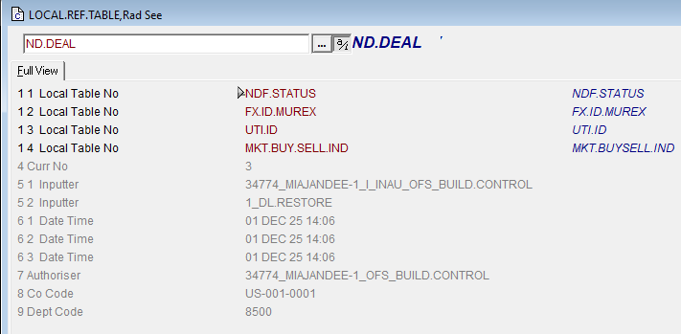

[Step 5] Installation again BCON BDER001-RLSE1270306.ND.DEAL.01 (Make sure you reload the BCON)

Make sure all records are fully authorized

[Step 6] Add as below SPB.FILE.PROCESS.PARAM,RAD SPB.FILE.PROCESS-FIXING.RATES

SPB.FILE.PROCESS.PARAM,RAD SPB.FILE.PROCESS-FIXING.RATES

FIELD | VALUE
1 Enabled | YES
2 Description | Load of REUTERS.RATES
3 Folder | ../bnk.interface/import/OTHERS/ACONTROL/FIXING.RATES
4 File Policy | FIRST
5 Files Per Run | 1
6 Sleep Time | 5
7 Max Attempts | 5
9 Routine | PROCESS.FIXING.RATES.INTRADAY
11 File Destiny | MOVE
12 Add Timestamp | YES
13 Allow Simultaneous | NO

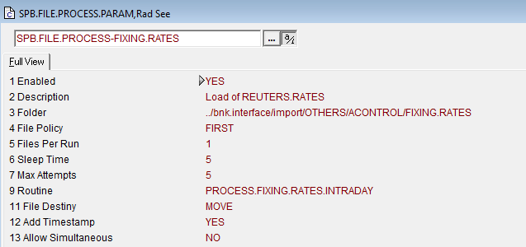

Make sure the update is fully authorized

[Step7]
7.1
Please add the following values in the record GLOBUS.CONST>DTCC.DATA and GLOBUS.CONST>DTCC.DIR
GLOBUS.CONST,RAD DTCC.DATA

FIELD | VALUE
1 16 Const Name | NDF.FILENAME
2 16 1 Const Value | NDFREPORT
1 17 Const Name | NDF.FILE.PREFIX.PROD
2 17 1 Const Value | DTS3.UP.C5
1 18 Const Name | NDF.FILE.PREFIX.UAT
2 18 1 Const Value | DTS4.UP.C5
1 19 Const Name | ORIG.CODE.PROD
2 19 1 Const Value | BSI
1 20 Const Name | ORIG.CODE.UAT
2 20 1 Const Value | TBS
1 21 Const Name | SYSID.DAILY
2 21 1 Const Value | 61210
1 22 Const Name | SYSID.ONLINE
2 22 1 Const Value | 60601

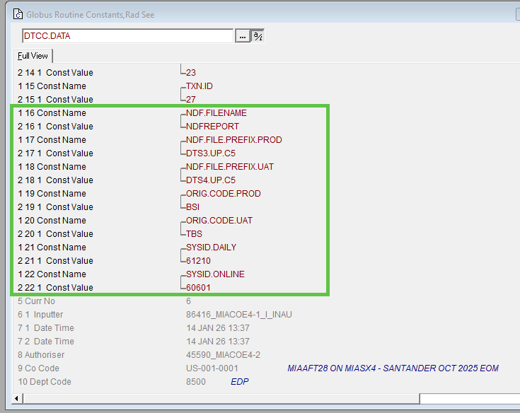

GLOBUS.CONST,RAD DTCC.DIR

FIELD | VALUE
1 6 Const Name | NDFDIR.ONLINE
2 6 1 Const Value | ../bnk.interface/export/documents/ndf
1 7 Const Name | NDFDIR.DAILY
2 7 1 Const Value | ../bnk.interface/export/NDF/DAILY

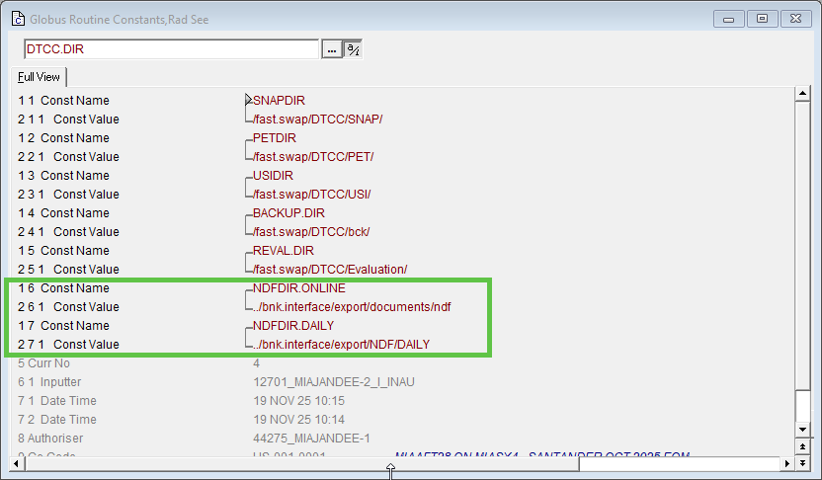
7.2
A new record should be created in COB.ALL.DOWNLOAD.PARAM with GROUP.ID as DAILY.PROCESS, MODE as ROUTINE and SEQUENCE as 1.
the routine SPB.GEN.NDF.DAILY.REPORT will be attached to the JOB.NAME.
The ID to be used: DAILY.PROCESS-104
COB.ALL.DOWNLOAD.PARAM, DAILY.PROCESS-104

FIELD | VALUE
1 Description | NDF DAILY REPORT
2 Sequence | 1
3 Process Enabled | ENABLE
4 1 Job Name | SPB.GEN.NDF.DAILY.REPORT
5 1 Mode | ROUTINE
6 1 Short Descript | NDF.DAILY.REPORT
23 Process Status | READY
24 Group Id | DAILY.PROCESS
30 1 Control Ref | RLSE1270306

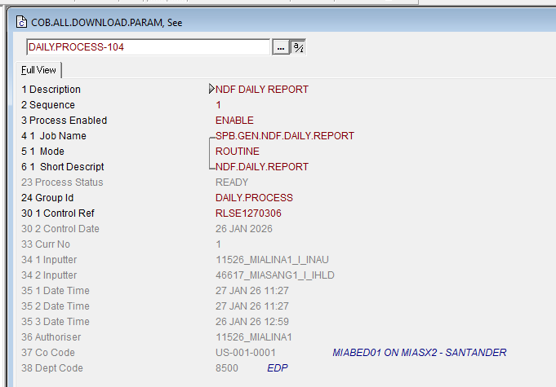

A New record to be created in COB.ALL.DOWNLOAD.PARAM:
COB.ALL.DOWNLOAD.PARAM, ALL.DOWNLOADS.3.50
FIELD | VALUE
1 Description | BSI.ND.FIXRATE
2 Sequence | 99
3 Process Enabled | ENABLE
4 1 Job Name | BSI.ND.FIXRATE
5 1 Mode | ROUTINE
6 1 Short Descript | BSI.ND.FIXRATE
23 Process Status | READY
24 Group Id | ALL.DOWNLOADS.3
30 1 Control Ref | RLSE1270306

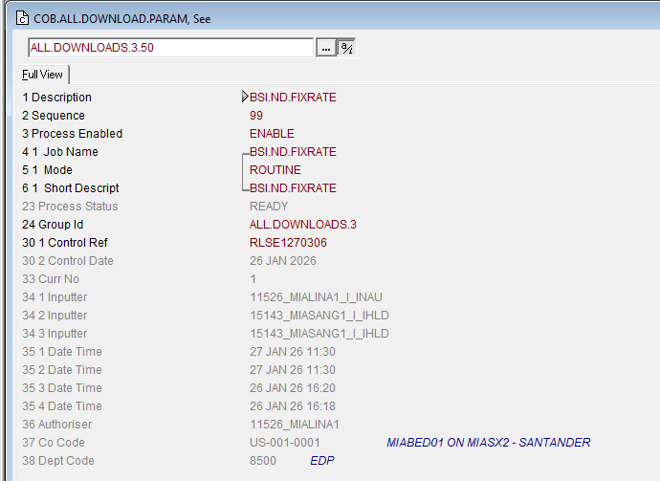

7.3
Edit the record DTCC on table CONNEX
SERVER.ID......... DTCC
------------------------------------------------------------------------------
1. 1 GB DESCRIPTION. Servidor DTCC
2 ENABLED........... NO
3. 1 COM.PARAM.NAME. IP
4. 1 COM. sftppki.us.dtcc.com
3. 2 COM.PARAM.NAME. USER
4. 2 COM. bsidtc
5. 1 APPLICATION.... PET
6. 1 PROTOCOL....... SFTP
7. 1 BACKUP......... NO
8. 1. 1 PARAM.NAME.. PASSTROUGH
9. 1. 1 P MIA-RELAY-PRE
8. 1. 2 PARAM.NAME.. PATH
9. 1. 2 P put
8. 1. 3 PARAM.NAME.. OPTIONS
9. 1. 3 P -i ~/.ssh/id_rsa_2048
10. 1. 1 RESERVEDE...
------------------------------------------------------------------------------
26 JAN 2026 14:24:26 USER (16 JAN) MIALINA1 [4452,5 PAGE 1 >>>3>>>

- This record is existing. After modifying field 4.1, press enter. You will go to field 5.1.
- Type >
- Fields 3.2, 4.2 will appear.
- When reaching 8.1.1
- These subvalues must be removed. Type – and press enter
- Do this 4 times, and the existing sub-values will be deleted. Enter 8.1.1. 9.1.1 as per above, press enter.
- You will be sent back to the command line, type ) and press enter.

Edit/Enter new record DTCC-PRE on table CONNEX
SERVER.ID......... DTCC-PRE
------------------------------------------------------------------------------
1. 1 GB DESCRIPTION. Servidor DTCC
2 ENABLED........... NO
3. 1 COM.PARAM.NAME. IP
4. 1 COM. sftppkipse.us.dtcc.com
3. 2 COM.PARAM.NAME. USER
4. 2 COM. bsidtccuat
5. 1 APPLICATION.... PET
6. 1 PROTOCOL....... SFTP
7. 1 BACKUP......... NO
8. 1. 1 PARAM.NAME.. PASSTHROUGH
9. 1. 1 P MIA-RELAY-PRE
8. 1. 2 PARAM.NAME.. PATH
9. 1. 2 P put
8. 1. 3 PARAM.NAME.. OPTIONS
9. 1. 3 P -i ~/.ssh/id_rsa_2048
10. 1. 1 RESERVEDE...
------------------------------------------------------------------------------
26 JAN 2026 14:43:43 USER (16 JAN) MIALINA1 [33606,5PAGE 1 >>>3>>>

7.4
Modify the COB.ALL.DOWNLOAD.PARAM>ALL.DOWNLOADS.EOD.64 to add the enquiry BSI.NDF.REVERSED.TODAY
COB.ALL.DOWNLOAD.PARAM, ALL.DOWNLOADS.EOD.64

FIELD | VALUE
8 1 1 Parameter | BSI.FOREX.REVERSED.TODAY;BSI.NDF.REVERSED.TODAY
30 1 Control Ref | RLSE1270306

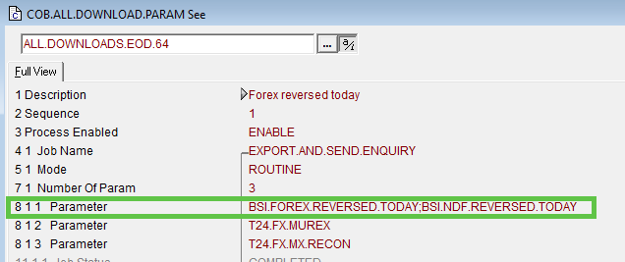

7.5.a
Modify the COB.ALL.DOWNLOAD.PARAM>ALL.DOWNLOADS.EOD.61 to add the below highlighted values
COB.ALL.DOWNLOAD.PARAM, ALL.DOWNLOADS.EOD.61

FIELD | VALUE
7 1 Number Of Param | 1
8 1 1 Parameter | FX
4 2 Job Name | SPB.RECON.FX.MUREX
5 2 Mode | ROUTINE
6 2 Short Descript | ND DEALS
7 2 Number Of Param | 1
8 2 1 Parameter | NDF
30 1 Control Ref | RLSE1270306

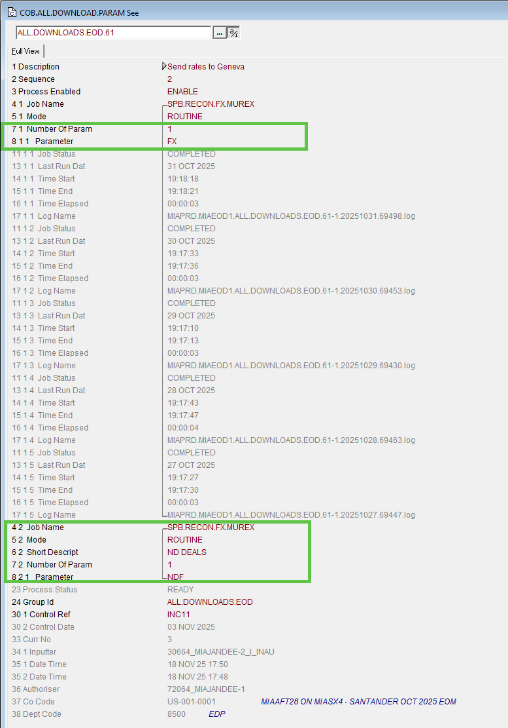

7.5.b

Modify the COB.ALL.DOWNLOAD.PARAM>VALUATIONS.16

7.5.c

Make sure all the following records in the COB.ALL.DOWNLOAD.PARAM has field Control.Ref = RLSE1270306:
COB.ALL.DOWNLOAD.PARAM DAILY.PROCESS-104
COB.ALL.DOWNLOAD.PARAM ALL.DOWNLOADS.3.50
COB.ALL.DOWNLOAD.PARAM ALL.DOWNLOADS.EOD.64
COB.ALL.DOWNLOAD.PARAM ALL.DOWNLOADS.EOD.61
COB.ALL.DOWNLOAD.PARAM VALUATIONS.16

7.6
Modify the record US0010001 in table COMPANY
COMPANY, US0010001

FIELD | VALUE
13 79 Pgm Autom Id | ND.DEAL M

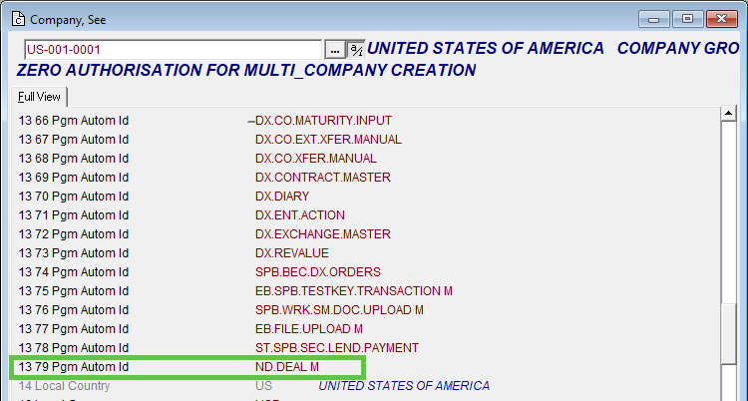

7.7
Modify the record 8000 from table DISPO.OFFICER to add below information:
DISPO.OFFICER,RAD 8000

FIELD | VALUE
2 1 Override Id | SPB.NDF.LIMIT
2 2 Override Id | SPB.NDF.EXPIRY
2 3 Override Id | SPB.FX.LIMIT
2 4 Override Id | SPB.ND.LINE
2 5 Override Id | SPB.FX.LINE
2 6 Override Id | SPB.FX.EXPIRY

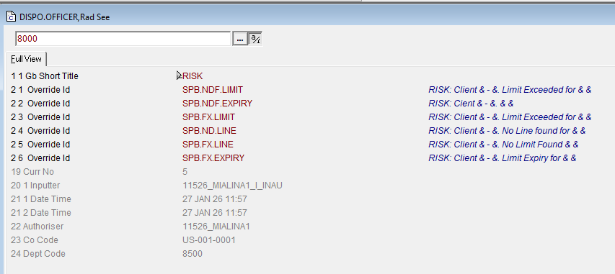

Modify the record 1000 from table DISPO.OFFICER to add below information:
DISPO.OFFICER,RAD 1000

FIELD | VALUE
2 7 Override Id | SPB.NDF.LIMIT
2 8 Override Id | SPB.NDF.EXPIRY
2 9 Override Id | SPB.ND.LINE
2 10 Override Id | SPB.FX.LINE
2 11 Override Id | SPB.FX.LIMIT
2 12 Override Id | SPB.FX.EXPIRY

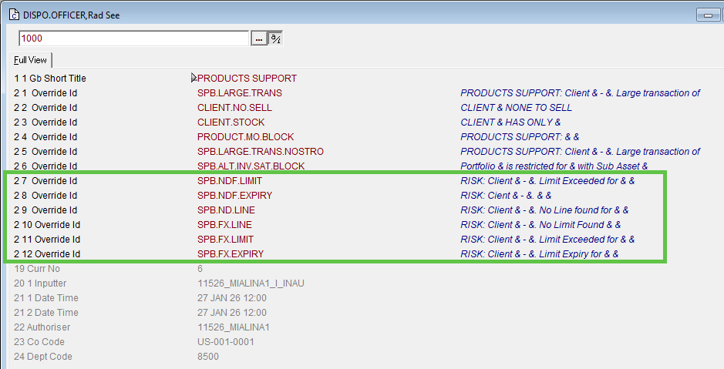

7.8
Apply permissions, dispo and menu entries specified in the document “NDF - Users and Profiles permissions.xlsx”

7.9
Modify the record “ALL” from table CUSTOMER.BLCK, and add the following information:
CUSTOMER.BLCK,RAD ALL

FIELD | VALUE
1 25 Departement | PRODUCTS SUPPORT
2 25 Message | OVERRIDE SPB.NDF.LIMIT
3 25 Override Error | OVERRIDE
4 25 1 Application | ND.DEAL
5 25 Active | YES
6 25 Comment | NA
9 25 Check Rtn | V.CHECK.LIMIT.AMT
1 26 Departement | PRODUCTS SUPPORT
2 26 Message | OVERRIDE SPB.NDF.EXPIRY
3 26 Override Error | OVERRIDE
4 26 1 Application | ND.DEAL
5 26 Active | YES
6 26 Comment | NA
9 26 Check Rtn | V.CHECK.EXPIRY.DATE
1 27 Departement | PRODUCTS SUPPORT
2 27 Message | OVERRIDE SPB.FX.LIMIT
3 27 Override Error | OVERRIDE
4 27 1 Application | FOREX
5 27 Active | YES
6 27 Comment | NA
9 27 Check Rtn | V.CHECK.LIMIT.AMT
1 28 Departement | PRODUCTS SUPPORT
2 28 Message | OVERRIDE SPB.ND.LINE
3 28 Override Error | OVERRIDE
4 28 1 Application | ND.DEAL
5 28 Active | YES
9 28 Check Rtn | V.CHECK.LIMIT.AMT
1 29 Departement | PRODUCTS SUPPORT
2 29 Message | OVERRIDE SPB.FX.LINE
3 29 Override Error | OVERRIDE
4 29 1 Application | FOREX
5 29 Active | YES
9 29 Check Rtn | V.CHECK.LIMIT.AMT
1 30 Departement | PRODUCTS SUPPORT
2 30 Message | OVERRIDE SPB.FX.EXPIRY
3 30 Override Error | OVERRIDE
4 30 1 Application | FOREX
5 30 Active | YES
9 30 Check Rtn | V.CHECK.LIMIT.AMT

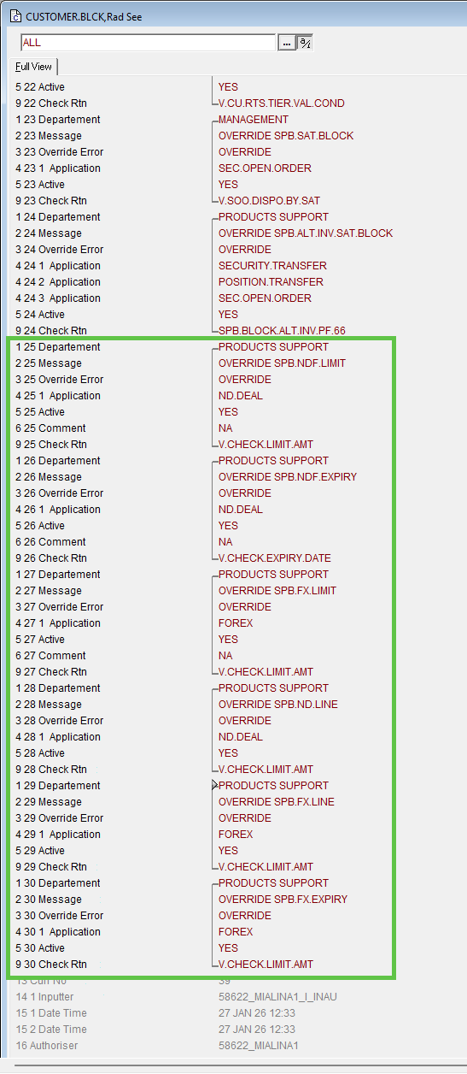

Routine List
Folder | Routine
DEV.BP | V.CUST.BLCK
REP.BP | RIG.INT
REP.BP | LOAD.SPB.CONTRACT
REP.BP | RPT.FX.POS
REP.BP | RPT.FX.CARTERA.NEGOCIACION
FX.BP | SPB.RECON.FX.MUREX
LIMIT.BP | BSI.NDF.CALC.REC.VALUES
LIMIT.BP | BSI.LMT.RTN.UPD.LIMIT.CONS
MEDEA.BP | M009DND
VAL2.BP | DETALLE.ND
VAL2.BP | CUST.POS.V3
SPB.BP | SPB.OPT.RISK.FACTORS.UPLOAD
BATCH.BP | GET.FX.PL
NDF.BP | SPBI.CUS.POS.ND.SEL
NDF.BP | SPBI.CUS.POS.ND.EXT
NDF.BP | SPB.SEND.ND.MUREX
NDF.BP | BSI.ND.FIXRATE
NDF.BP | DE.NDF.DATA
NDF.BP | VAL.BUYSELL
NDF.BP | PROCESS.FIXING.RATES.INTRADAY
NDF.BP | SPB.GET.ND.MUREX
NDF.BP | V.VAL.STLMT.CCY
NDF.BP | PROCESS.FIXING.RATES.IMPL
NDF.BP | V.CHECK.EXPIRY.DATE
NDF.BP | V.CHECK.LIMIT.AMT
TWR.BP | E.OPEN.IMAGE.NDF
ENQ.BP | E.ASSET.FX.ID
ENQ.BP | E.GET.DEAL.AMOUNT2
ENQ.BP | E.DETALLE.POS
ENQ.BP | REPORT.CALL.MARGIN.SUS
ENQ.BP | REPORT.CALL.MARGIN.CUSHION
ENQ.BP | REPORT.CALL.MARGIN
ENQ.BP | E.PERC.ASSET.ID
ENQ.BP | E.ASSET.MC.ID
ENQ.BP | E.ASSET.FX
ENQ.BP | E.CUP.ND
ENQ.BP | FX.RISK.REPORT
RATES.BP | PROCESS.REUTERS.RATES.IMPL

DEV.BP | SPB.GEN.NDF.DAILY.REPORT
DEV.BP | SPB.GEN.NDF.ONLINE.REPORT

CID.BP | EXP.CID.HELPTEXT.MAINMENU
CID.BP | EXP.CID.USER
CID.BP | EXP.CID.HELPTEXT.MENU
CID.BP | EXP.CID.USER.SMS.GROUP

Rollback plan

[Step 1]
Rollback snapshot taken just before release started.

